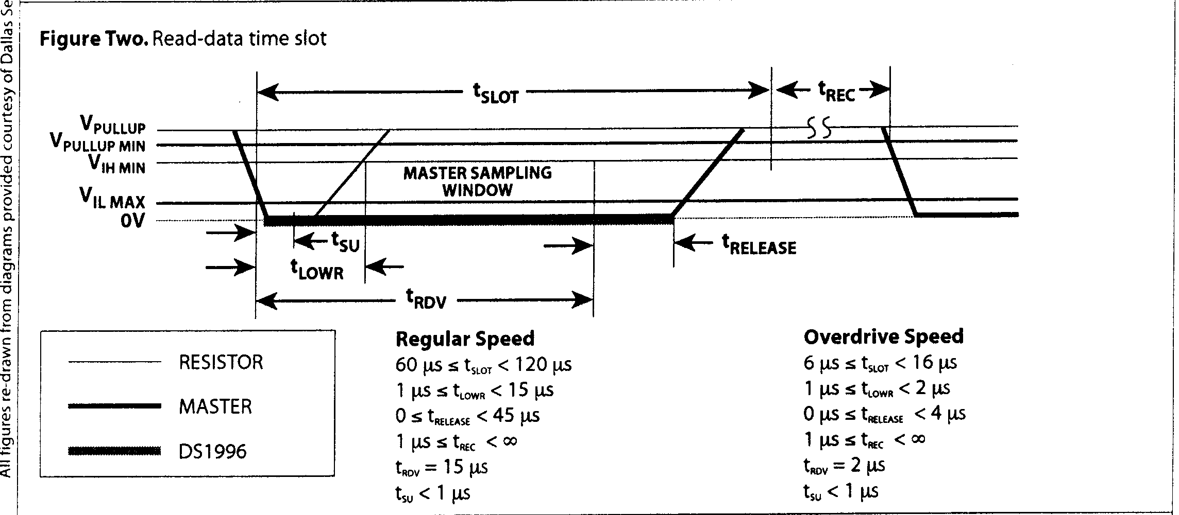
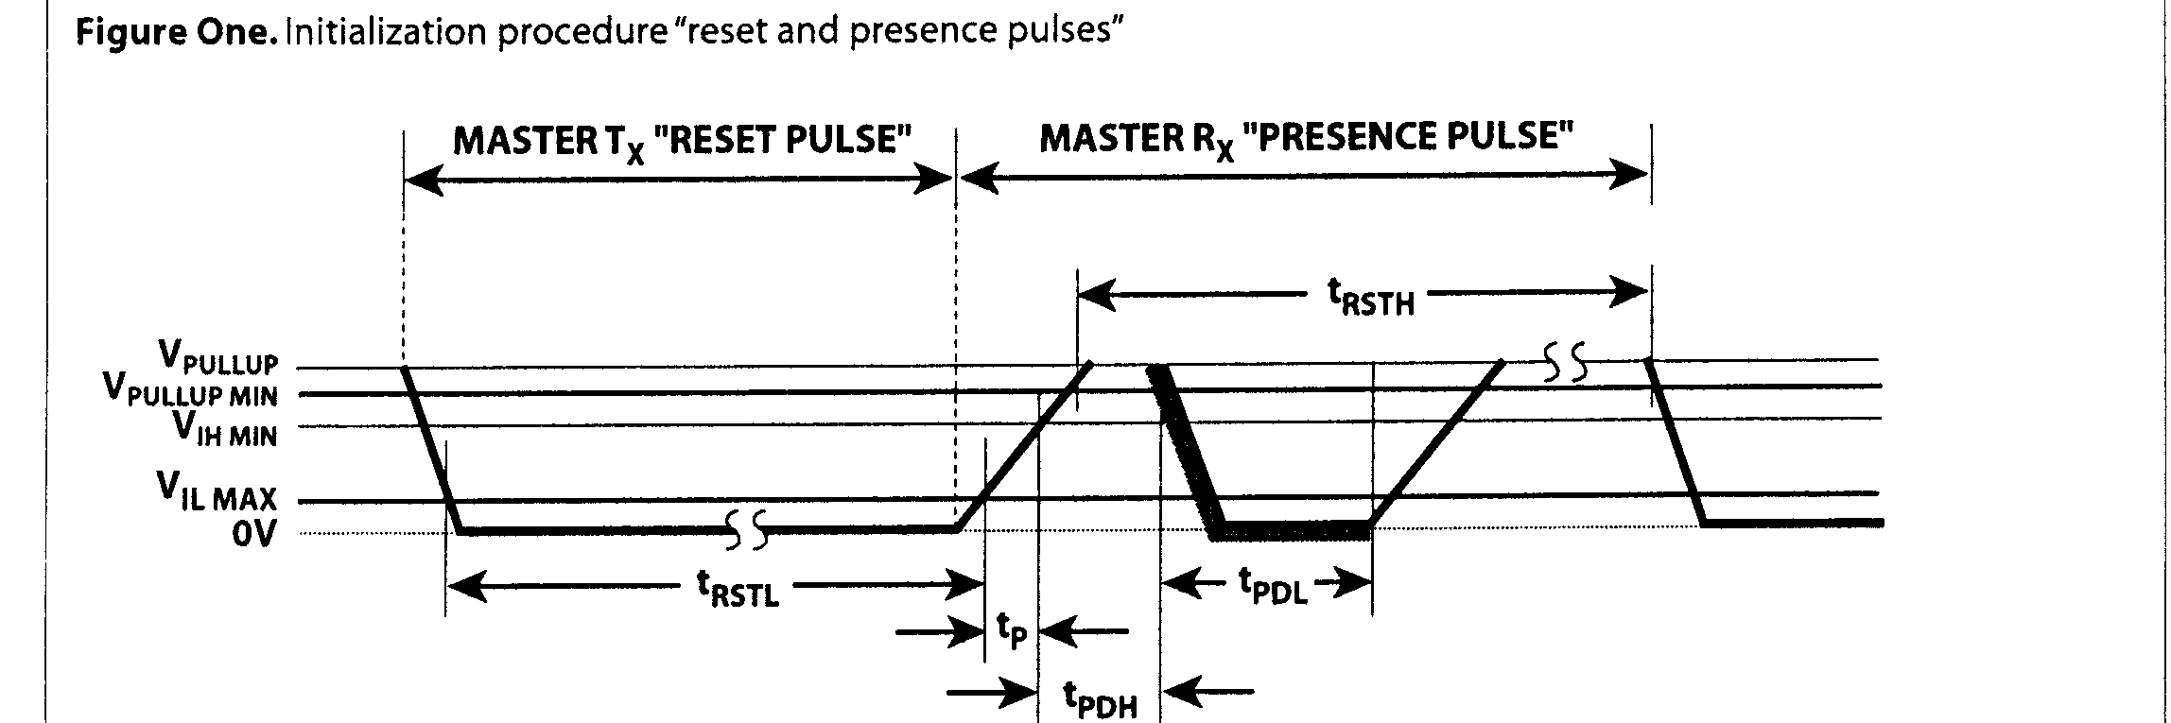
2. The Code
Having described the basic processes, now we can look at the code which does all of this (refer to the listings). This is where some detailed knowledge of the 68HC1 I's opcodes and opcode execution times is needed; this is where we start counting cycles!
2.1 Coding Preliminaries
Before I begin the detailed discussions of the coding, as Jarrah Computers are a Forth-based company, we have developed our own 68HC 11 assembler and therefore must provide some background to our style of coding, just to help you understand the listing.
Forth Dimensions XXI.1,2
The assembler uses reverse Polish assembler, so what would normally be written as, say, LDD # $1234 ( load'D' immediate with $1234) is written (HEX) 1234 # LDD,andtheopcode names all end with , to indicate the point in the code where assembly actually occurs. We can also say VARIABLE-NAME LDD and the like.
The stack referencing used in this code is similar to that of many Forths: the Y register points to the TopOfStack (High byte), so we use , Y addressing mode: 0 , Y references TOS, 2 , Y references NOS, and so on. We also have our own definitions for RAM locations: RAM arrays are called RARRAY, used n RARRAY Name. VARs are our VARIABLES (a "2" RARRAY), and CVARs are single-byte variables. The HC I I has two accu-
49
RESISTOR
- MASTER
~ DS1996
Regular Speed
48005 tRSTL "" 00
480 [ts:s t < oo (includes recovery time)
15 [ts!s,,, < 60 las
60 las s t,, < 240 las
Overdrive Speed
48 las z t,,, < 80 Vs
48 lAs !s t,, < -
2 [is :s t,,, < 6 lAs8 I.Ls :s t,, < 24 p

