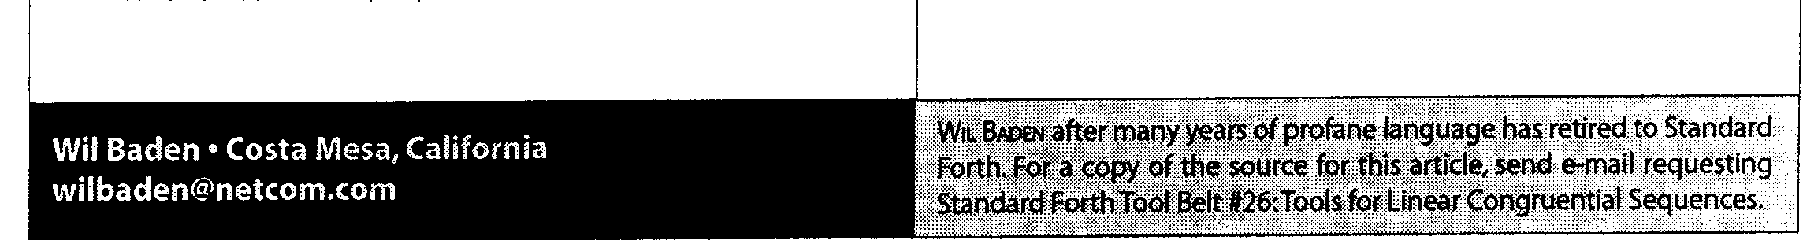
22 : RAND-UNIF ( +n -- u ) 2* RAND-NEXT UM* NIP ;
24 :GO CR CR .1' Distribution Using Multiply " CR
25 BINS 10 CELLS ERASE
26 20000 0 DO
27
28
29
30
31
32
\ 9 Digit Number
1000 MIL RAND-UNIF ( u)
\ Into 10 BINS
100MIL /
CELLS BINS + 1 SWAP +!
LOOP ; GO
34 :GO
35 10 0 DO
36 CR I CELLS BINS + @
37 DUP 4 R SPACE
38 50 [CHAR] * EMITS
39 LOOP GO

Distilbution using multiply:
1977 2042 1974 2024 2021 2007 1981 1991 2001 1982
[ THEN]
Tools for Linear Congruential Sequences
Note: The preceding "Tool Belt" article was #9. From now on, the "Tool Belt" article number will agree with the current "Stretching Forth" article number. Using two sets of numbers confuses me.
Definitions for the non-standard words in the current "Stretching Forth" article are given here for your convenience. Most of these have appeared in previous articles, and will have little or no discussion.
1 : MACRO ( "name <char> ccc<char>"
2 CHAR PARSE POSTPONE SLITERAL
POSTPONE EVALUATE
POSTPONE ; IMMEDIATE
6 MACRO :GO " ANEW NONCE (GO)
7 MACRO GO " (GO) NONCE
9 : POSSIBLY ( "word"-- )
10 BL WORD FIND ( xt flag)
11 ?DUP AND IF EXECUTE THEN
13 : ANEW ( "name" -- )
14 >IN @ POSSIBLY >IN ! MARKER
16 \ NOT is equivalent to '0=' or 'INVERT'.
17 MACRO NOT " 0= "
19 MIL is convenient for large numbers.
20 MIL ( n -- 1000000**n ) 1000000 * ;
22 EMITS displays a CHAR n times.
23 EMITS ( n CHAR -- )
24 SWAP 0 ?DO DUP EMIT LOOP DROP
Forth Dimensions XXI.1,2
47

