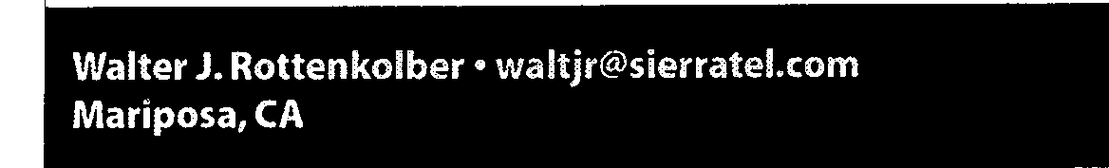
Forth and the kyternet..,~
FORML21
The 21st annual FORML Conference was held November 21-23, 1999 (Friday through Sunday) at the Asilomar Conference Center. Asilomar is located west of Monterey, California, on a hillside that overlooks a wide sandy beach and the Pacific Ocean beyond. Most residence quarters and meeting rooms are clustered on the hillside. The cafeteria, chapel, auditorium, and administration building huddle at the base of the hill near the shore. The buildings have a natural, rustic design, and the pace at Asilomar is unhurried. The atmosphere is more that of a spiritual retreat, despite the number of conferences being held there.
The weather started off blustery, and rain began to fall by dinner time and on through the evening. By morning, however, the sky was clear and the surf was up. it was the same on Sunday when an outdoor barbecue was served for lunch, ending a picture-perfect day.
The Forth Interest Group was able to arrange for more comfortable rooms this year, especially for those of us who chose to double up as an economy measure. The meals were outstanding. Definitely a weekend to leave the diet behind.
The majority of those attending this FORML came from the United States, but we also welcomed two intrepid travelers from overseas. Federico de Ceballos came from Santander in northern Spain, and Charles Esson made the long flight from Ballarat, Victoria, in Australia.
FORML21 began at 3:30 p.m. with Richard Wagner presenting a tribute to Robert R. Reiling, who passed away a few months earlier. Mr. Reiling had guided FORML conferences for nearly 20 years, ever since they had been held at Asilomar. Like all those who work with quiet competence, his efforts will be appreciated most by those who must shepherd the conferences in the future.
The format of the conference then was outlined.
Though the theme of this year's FORML was "Forth and the Internet," the papers ranged over several topics:
Forth and Networking
Encryption
Text Processing Forth Machines Forth Philosophy Teaching Forth
I i
I
I
i
Charles Esson presented three papers on ColdForth, a Forth designed to run on Motorola's ColdFire family. This project was started two years ago after Motorola announced that the 68K family would be phased out. For fourteen years, Color Vision Systems, the company Charles is with, had been using the Motorola 68K family of chips, building a large base of Forth, assembler, and proprietary code. All of it was threatened with obsolescence. After exploring alternatives, they
Forth Dimensions XXI.1,2
decided on ColdFire and Forth. Commercial Forths were looked at, but a critical requirement was preemptive multitasking, so they decided to roll their own.
To avoid a future problem with "disappearing hardw-,
ColdForth is being designed to be as portable as possible. To achieve this, the bulk of it is being written in ANS Forth. The compiler will do some optimizing to increase speed. Device drivers are coded as objects, so kernel words handling input/ output or mass storage don't need to be rewritten-the appropriate driver is simply plugged in. The kernel code is being made GPLLable, and its source will eventually appear on the Internet. The hope is that others will adapt it to other chip families, and extend the list of device drivers.
Esson's first paper described the design of the TCP/IP proto-
col as a set of objects, just another device driver. In addition, an I interface was developed to allow transfers on an ethernet link.
His second paper discussed the reasons for requiring a preemptive multitasker, and the design considerations to ensure its proper function.
The third paper described a heap to allocate and release memory for the datagrams processed by TCP/IP. The challenge was that it had to work without the benefit of an MMU, be written in Forth, and still be fast.
Federico de Ceballos dealt with the challenge of connecting a Forth program to a Siemens AS990 system. This is a distributed computer system having multiple nodes tied together by an ethernet. Each node is composed of a VE486 processor card, and a CP486 ethernet card. Each card has its own operating system (MICROS), and the two cards COMMLInicate via a MicroNET system using a TCP/IP stack! Federico presented the Forth code used to interface his program with the MicroNET C functions that handle data transfer. There was a high priority on reliability, as the program located the position of control rods in a nuclear reactor.
Skip Carter of Taygeta Scientific showed how to subset TCP/ IP. TCPAP is not a monolithic structure; instead, it is a collection of protocols. Not all are needed in a dedicated system, and careful pruning can simplify the code.
Wil Baden presented two papers on encryption.
The first was on the SHA-1 Secure Hash Algorithm. This is widely used to secure the Digital Signature Algorithm, His Forth code is designed to run on big-endian or little-endian i Forths without change. Though it does much better on 32bit systems, he has a 16-bit version available, including one for Quartus (Palm Pilot) Forth.
The second, "Solitaire," was about an encryption method used by a Soviet spy, and described by David Kahn in Kahn on Codes. The original method used a standard deck of 52 playing cards plus the two Jokers.The cards are arranged in Bridge
Continues on page 77.
mm,rig"Helives"out in Wafte:r as!tetired and. drifted. Va~ iroip proqra~ I
~4g:e:6:i th niverso! wherehe finds interest in the
164~8un near t. e,
histoty6f computers, Fbrt,h,,Ai-idth,eimpletnentAtion of the odd
algorithm.43

