The Open Interpreter Word Set
T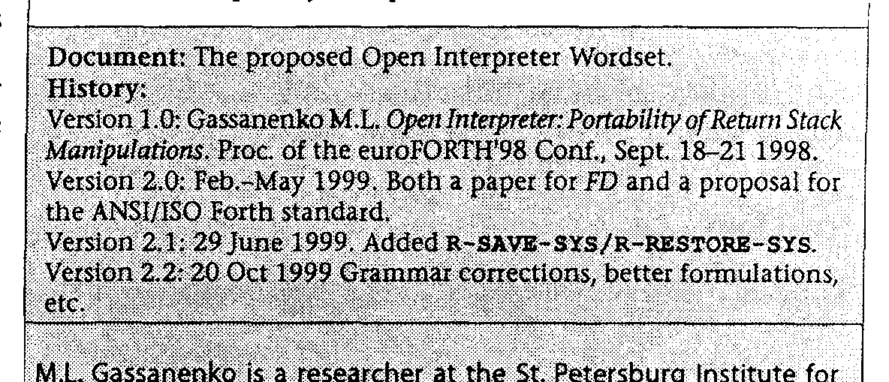
This paper may be distributed freely in hard copy or electronic form provided that it is not changed, and a reference to the original publication is given. Citations (and partial reproduction) are allowed, but they must not misrepresent the intent of this paper, and a reference to the whole document must be given. (The purpose of this requirement is to guard against releases of incompatible "improvements" of this speciocation, because this would be a hindrance to the primary purpose of this document, portability of return address manipulations.)
Abstract
The concept of Open Interpreter makes the techniques of changing the control flow via return stack changes architecture-independent. The five classes of open interpreter systems
I allow programmers to choose the most adequate degree of compromise between portability and convenience of programming. The Open Interpreter specification presented in this paper may be used as an additional chapter to the ANSI/ISO standard.
1 1
1 The purpose of this paper
The purpose of this paper is to introduce a specification which would allow portable use of techniques that are currently (in March 1999) outside the scope of the ANS Forth standard. They are: manipulations with return addresses, backtracking, keeping literals in threaded code, user-defined control structures (ANS Forth supports the latter in a restricted way). Such techniques as user control over code generation, dynamic code generation, de-compilation will also benefit.
The value of some of the mentioned techniques is arguable, but, in fact, sufficient motivation is provided by the two following items:
1. portability of return address manipulations (which, in particular, means portability of backtracking);
2. portability of implementation techniques (in particular, of access to literals in threaded code). Portability of
implementation techniques is valuable for cross-compilers and embedded systems: people often need to port a
system to a new target keeping its internals the same.
To prevent possible misinterpretation, I have to expand on the second item. It is good when implementation tools are portable. They will not be as much portable as Core words, and the structure of the standard with the Open Interpreter specification reflects this: the code that e.g. accesses in-line data requires the system to support the Core word set, plus the optional Open Interpreter word set, plus the optional Open Interpreter In-line Data Access word set. It is up to the programmer to realize that some method is less portable than another, and to use it adequately. It is a bad style to mix low
level and application-level code, but a programming language standard cannot and must not prevent bad style.
The Open Interpreter word set will be proposed for inclusion into the standard, but first of all, the procedure requires this item be included into the technical committee (TC) agenda. It is possible that TC will not be willing to spend time on it. On the other hand, portability of the mentioned Forth techniques and inclusion of corresponding words into the standard are related, but different purposes. The proposed specification works even not being a part of the standard.
2. The approach
Let us formulate the main contradiction:
• the "classical" architecture is backed by a wide common practice, it is both simple and adequate to the techniques of return address manipulations, but there are also
unclassical" architectures, and therefore the code written for the "classical" model is not much portable;
• it is possible to write programs as if the return address size is unknown, the code will be portable, but cumbersome; this approach is not justified if the program will never be ported to a system with return addresses wider than one cell; in addition, double-cell return addresses are not widely used today;
• The compromise, "intermediate" solutions may be adequate for some architectures, but such compromises lose both advantages: they are neither backed by wide common practice nor widely portable.
The solution is to introduce multiple classes of Open Interpreter systems (namely, five). A "classical" system is of Class 1, and Class 5 is a probably Harvard system with probably multiple-cell return addresses and probably different size of code and data memory address units. A Class 1 system may be considered as a particular case of a Class 5 system.
The code written for higher classes may run on lower classes, but not vice versa. Therefore, programs written for higher classes are more portable. In exchange, programming for lower classes is less cumbersome (the word 'cumbersome' means 'inadequately complex').
Forth Dimensions XXI.1,2
31

